Inha University in Tashkent

Fall 2019

OOP1 – Lab Assignment #2

Topic: understanding flowchart, relational operator if-else control statement

1. Write C++ program to read two integer values and demonstrate relational operators in C++.
2. Write C++ program for following flow chart 1 (Increase price of part number 203)

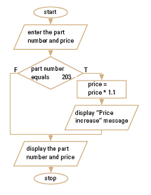

1. Write C++ program for following flow chart2 (calculate commission).

